Milestone 3

Name: Matthew Trinh

Candice Garcia

Bryan Cabrera

**Report Details**: Suppliers deliveries and Wine Distribution

The purpose of this report is to keep track of inventory of things within the warehouse. This can be anything from the wines that Bacchus WInery produces, to the supplies needed to ship out and produce the wine. Also how often the shipments are coming in.This report also covers the distribution of wine through our shipping partners

**Products**

| Supplier | Item | Item ID | QTY | Date Received |
| --- | --- | --- | --- | --- |
| ULine | Bottles | 001 | 1000 | 4/1/2024 |
| ULine | Cork | 021 | 1000 | 4/1/2024 |
| Staples | Labels | 654 | 5000 | 4/6/2024 |
| Staples | Boxes | 456 | 5000 | 4/6/2024 |
| Harbor Freight | Vats | 141 | 500 | 5/5/2024 |
| Harbor Freight | Tubing | 121 | 250 | 5/5/2024 |
| ULine | Bottles | 001 | 1000 | 4/15/2024 |
| ULine | Cork | 021 | 1000 | 4/15/2024 |
| Staples | Labels | 654 | 5000 | 4/20/2024 |
| Staples | Boxes | 456 | 5000 | 4/20/2024 |
| Harbor Freight | Vats | 141 | 500 | 5/19//2024 |
| Harbor Freight | Tubing | 121 | 250 | 5/19/2024 |

**Distribution**

| Distributor | Item (wine ID) | Out For delivery (date) | Expected delivery (date) | Delivered (date) | Received by |
| --- | --- | --- | --- | --- | --- |
| UPS | 2324 | 5/20/2024 | 6/3/2024 | 6/3/2024 | Will |
| UPS | 3678 | 5/27/2024 | 6/4/2024 | 6/1/2024 | John |
| UPS | 7982 | 6/6/2024 | 6/20/2024 | 6/20/2024 | James |
| UPS | 8990 | 6/7/2024 | 6/20/2024 | 6/15/2024 | Jason |

Report 2 Wine Sales Report:

A couple of questions were brought to our attention.

Are wines selling as Bacchus Winery thought?

Is one wine not selling?

This report will gather information using the wine and sales review table.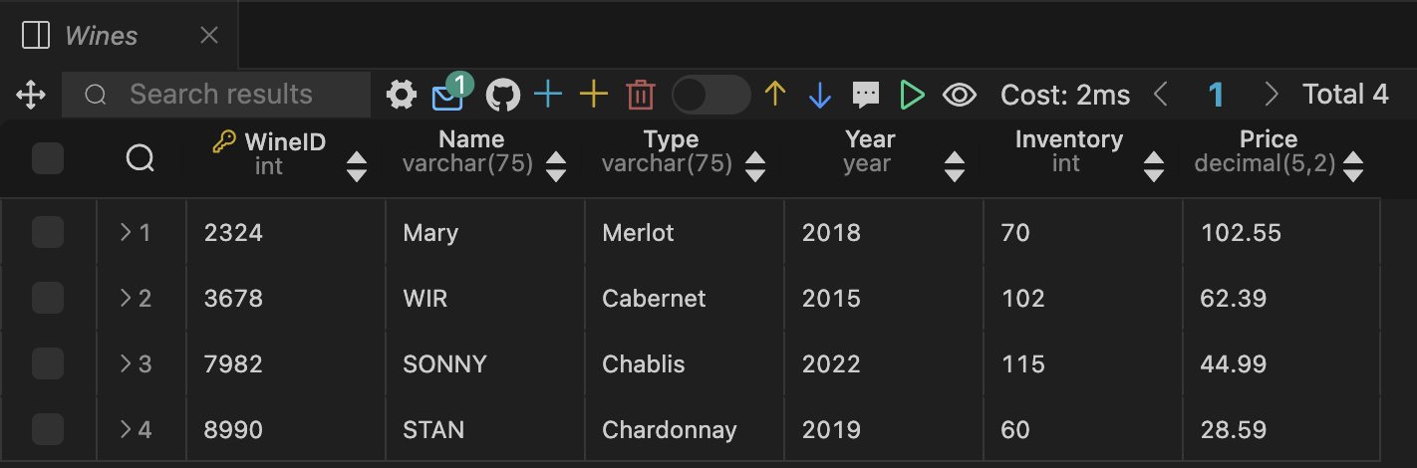

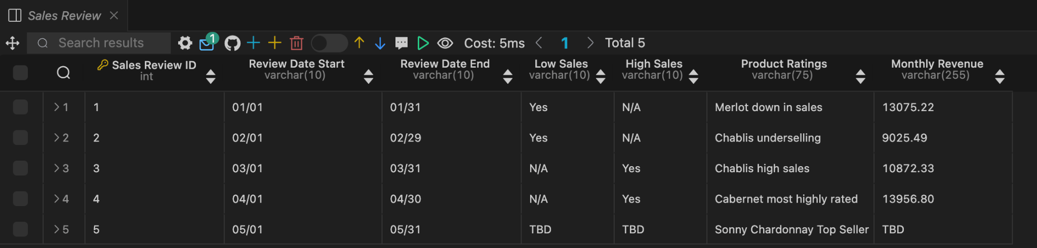

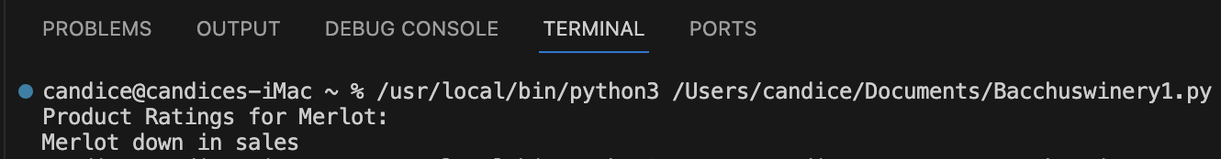

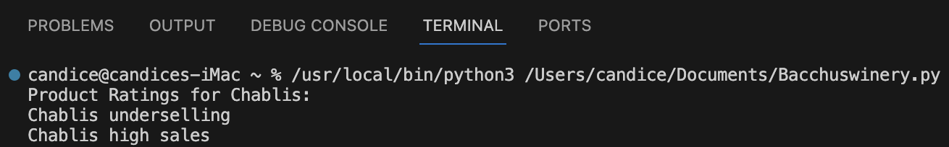

**Report 3:** Employee Work Hours Report: -For the Bacchus Wine company it’s important to know which employees are actively working and for how long. Not only is it important to understand which employees are being most productive but for Payroll purposes it’s also important to know how many standard hours, and overtime hours are worked in order to properly pay their employees. Therefore this report pulls employee names, overtime hours, and total hours worked from the database.

Results of query:

